Databricks Assignment [30.12.2023]

By Karthikeyan K R

**Creating a cluster in my Databricks**

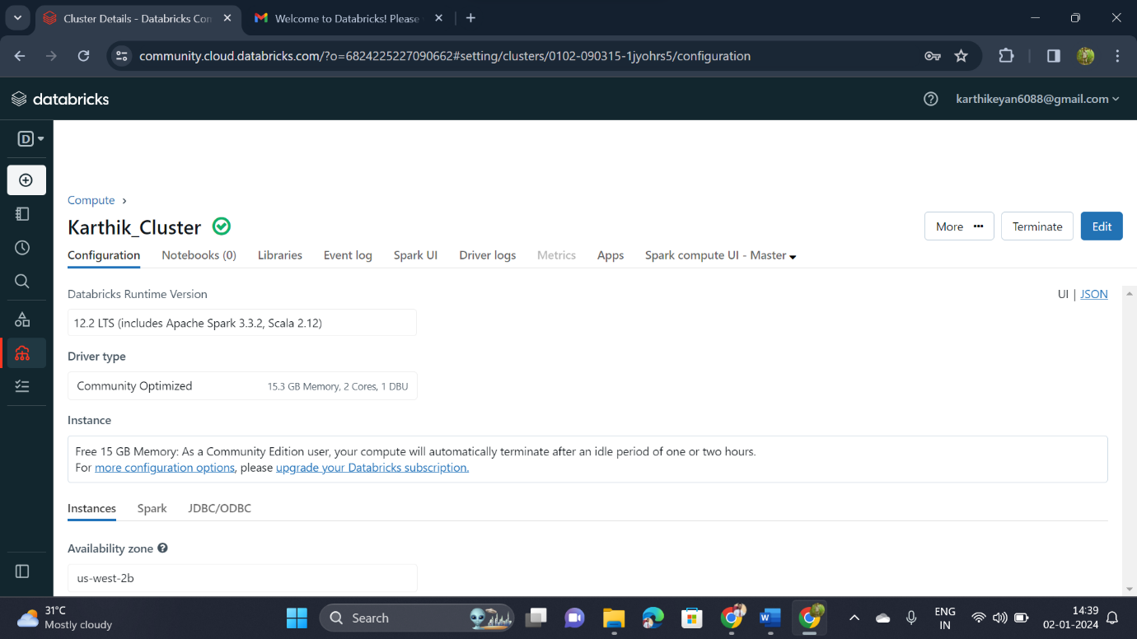

**Creating a notebook**

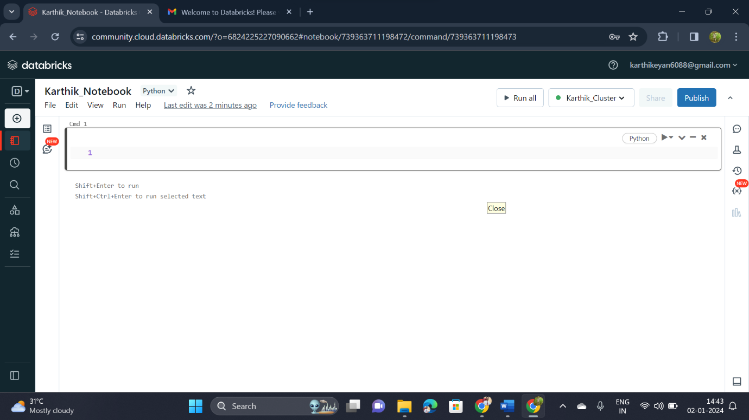

**Adding the created cluster to my notebook**

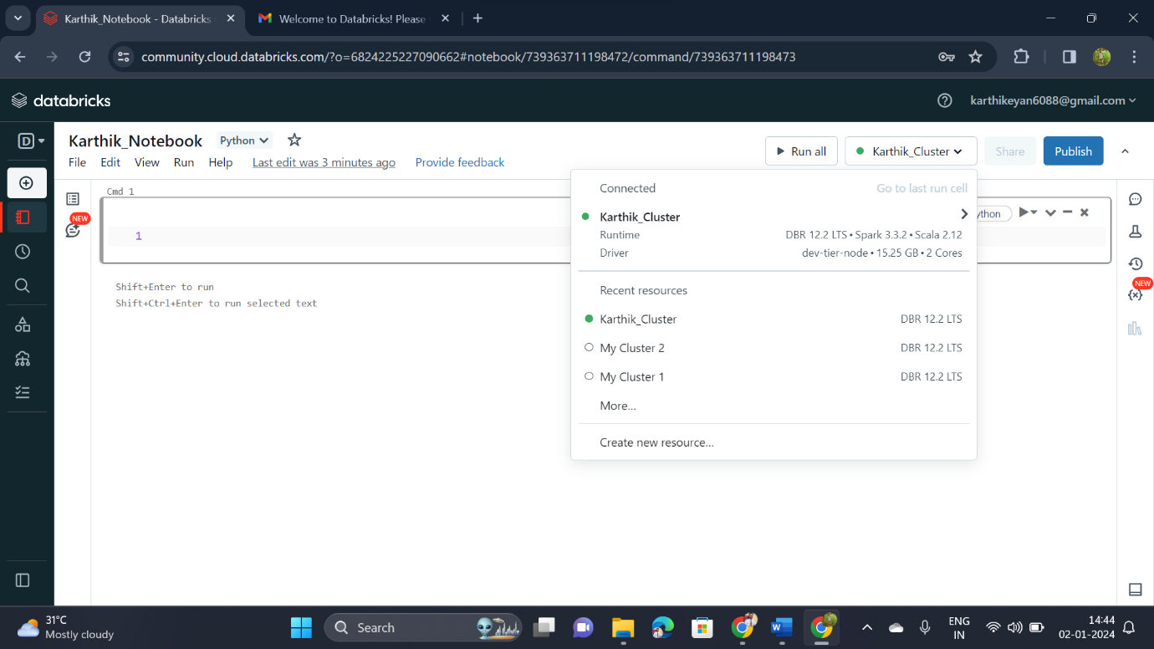

**Loading my csv file using spark program**

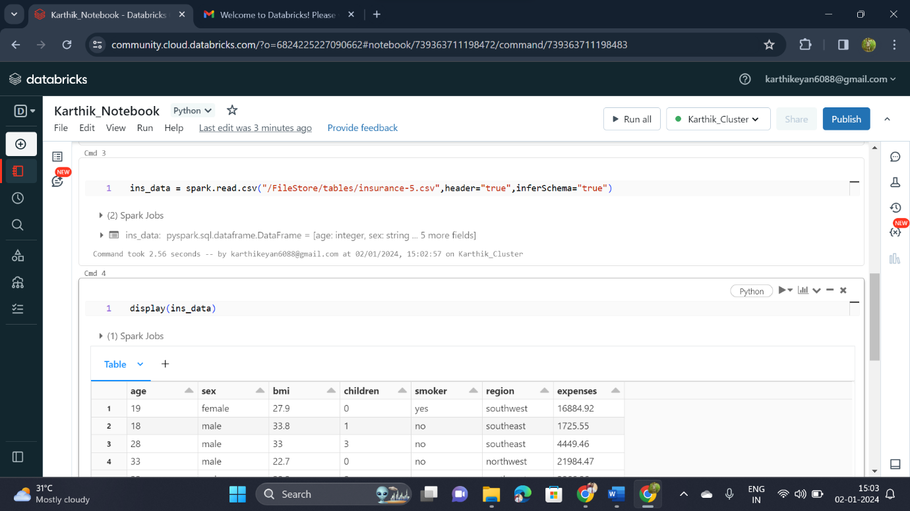

**Displaying the data of my csv file**

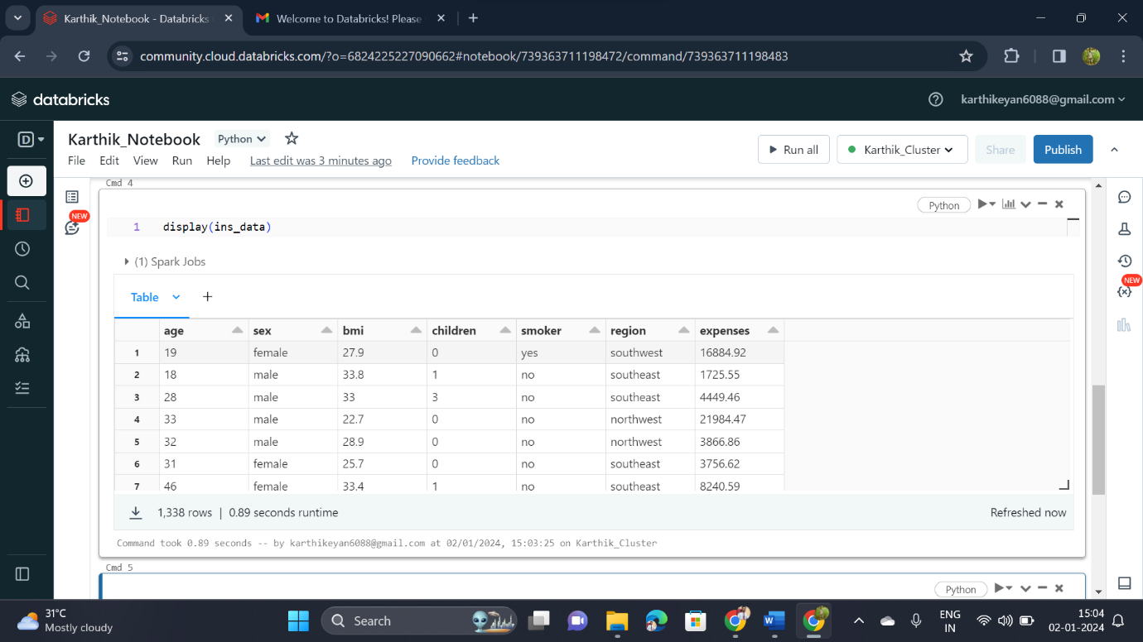

**Visualization of the data in csv file**

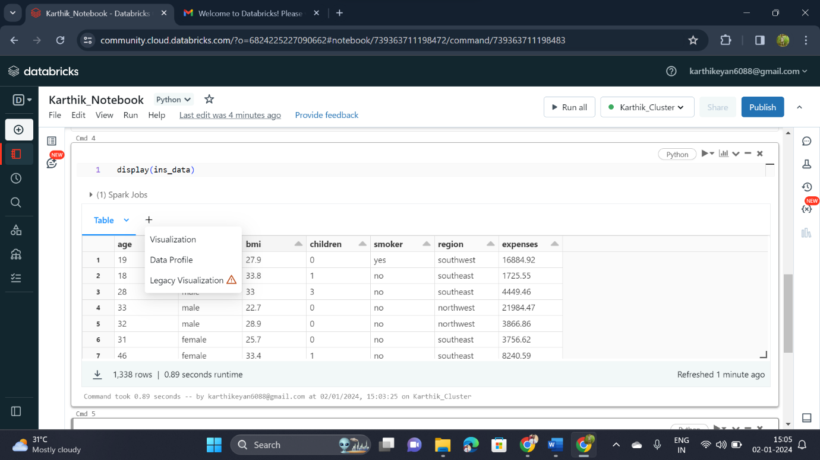

**Choosing type of chart and the required columns**

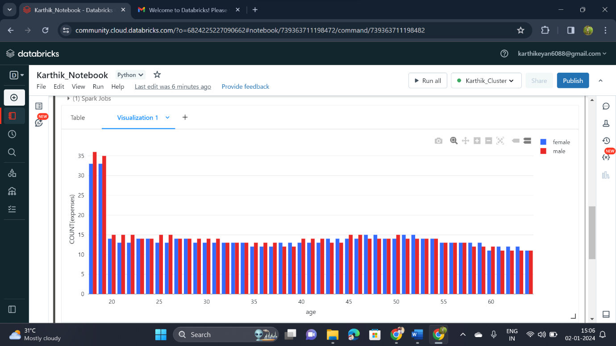

**Data Profiling**

